|  |
| --- |
| User Guide  Smart Night Safari Chatbot  25/08/2019 | v1.0 |



|  |  |  |
| --- | --- | --- |
| Team name: NUS-ISS F4 |  |  |
| Ma Weizhong, Xu Kaixin, Yu Xiaoxi, Zhang zhiling  CA project for Cognitive System Course in NUS-ISS Intelligent System |  |  |

Contents

Our Approach 2

Requirements 3

Dependencies 3

Supported User Interfaces 3

财务摘要 4

财务报表 4

财务状况报表 4

综合净利表（损益） 5

所有者权益变动表 5

现金流量表 5

财务报表备注 6

会计科目 6

债务 6

债务 6

持续经营 6

或有负债 6

要点 6

独立审计报告 7

审计员的报告 7

# Our Approach

Our processing of user input is mainly divided into two modules. First, the query matches the user's input with the intent defined in Google Dialogflow. If the corresponding intent matches, it will be processed by the intent and entity in Dialogflow. If the corresponding intent does not match the user's input, it will be transmitted to python by Dialogflow, processed by TF-IDF method and Cosine Similarity, and the answer to the user's input question will be returned. This application is built using Google Dialogflow technology and integrates Python to provide dynamic response. Dialogflow provides predefined entities that can be used to categorize the extracted parameters, while allowing the creation of custom entities. The agent matches the user's utterance to intent, extracts identified parameters, and returns a response, either static or dynamic. The purpose of this particular agent was to answer questions about the curriculum of the administrative education programme.

# Requirements

1. **Dialogflow**: API to retrieve a set of trained intents and entities from user’s continuous queries.
2. **Google actions**: API to deploy our project on google assistant interface, enabling rich and pure text response.
3. **Ngrok**: Expose local server address to a remotely accessible Internet url.

## Dependencies

1. Dialogflow
2. Anaconda3
3. Python frameworks: flask, nltk, …
4. Ngrok

## Supported User Interfaces

1. Google Assistant mobile app (Recommended), on IOS 9.0+ iPhones/ Android 5.0+ phones, etc.;
2. Actions console simulator;
3. Web demo, viewing on Google Chrome version 74 and above.

# Deployment

## Prerequisites

1. Install anaconda3 from <https://www.anaconda.com/distribution/> correspond to your OS version;
2. Download ngrok binary from <https://ngrok.com/download> correspond to your OS version;
3. Both installations above should be added to your environment before starting our product.

## Configure Dialogflow

1. Git clone our project repository to your local machine, by either run:

git clone <https://github.com/harry0916/NUS_Chatbot_F4.git>

or simply direct to our git repo and download it as a zip.

1. [Optional], if you don’t have a google account, please create one here: <https://dialogflow.com/_d/signin?continue=https%3A%2F%2Fdialogflow.com%2F>. skip this step if you have signed up already;
2. Log in to the dialogflow console: <https://console.dialogflow.com/api-client/#/login>;
3. Create a new agent on the up-left side panel, name it as whatever you like:

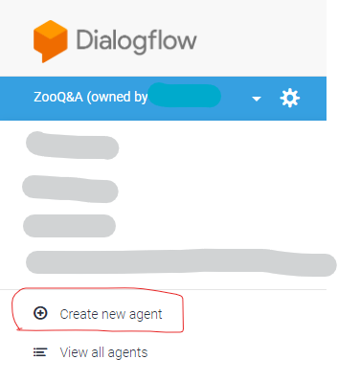

1. Click gear button in new agent, select “Import From Zip” option under “Export and Import” panel:

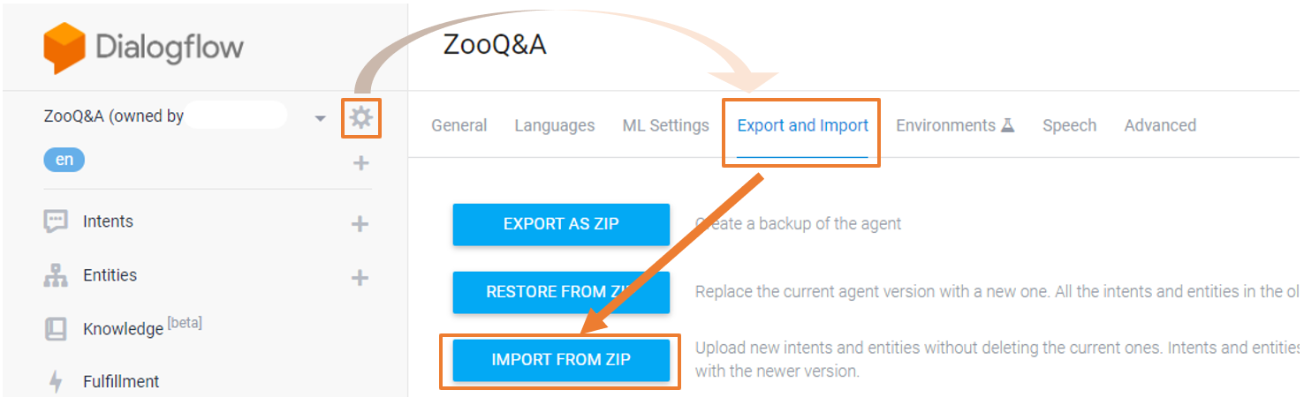

1. Click “Select File” and select “ZooQ&A.zip” file under [project root]/SystemCode/ directory. Then follow the displayed instructions to proceed importing:

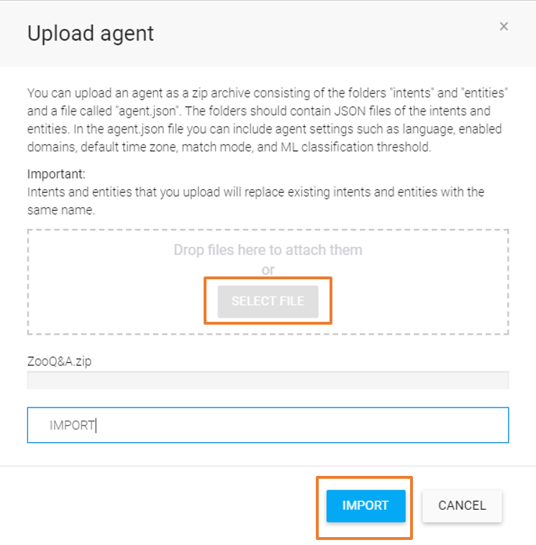

## Run backend script

1. Test anaconda binary is detectable by your cmd/shell: open your cmd/shell and run this command: conda –version, ensure it shows the right version you have installed;
2. Start the server:
   1. Win10 users: double click the “setup.bat” batch file under [project_root]/SystemCode/intelligentchatrobot directory.
   2. Linux users: navigate your terminal to the [project_root]/SystemCode/intelligentchatrobot directory, and run:

bash setup.sh

## Start a ngrok session

1. Open another terminal/command line tool;
2. Run ngrok http 4300 to generate a url;
3. Copy the highlighted url to your clipboard;

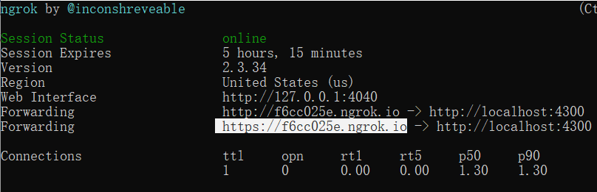

1. Open the Dialogfow console in your browser, and paste the url to “Fulfillment -> Webhook -> URL” column, REMEMBER TO SAVE before proceed.

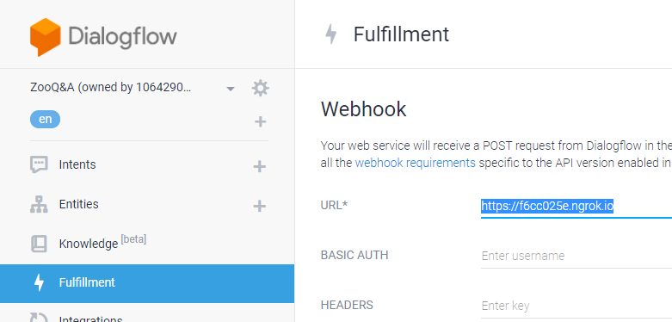

1. Notice that every session is only valid for 8 hours if you downloaded the free version, beyond that, ngrok service can be fragile from time to time, so if anything works abnormally, consider to repeat step 2-4.

使用本部分提供关于财务信息的简短摘要，其中突出显示要点。此文档中的一些示例文本表明了所应用样式的名称，以便你可以再次轻松地应用相同格式。

例如，这是“列表项目符号”样式。

下面是另一个采用“列表项目符号”样式设置格式的句子。

在“插入”选项卡上查找易用的工具，例如用于添加超链接、插入批注或添加自动页码的工具。

|  |
| --- |
| 坐在桌子旁工作的人 |

在计算机、平板电脑或手机上使用 Word 查看和编辑此文档。在 Windows、Mac、Android 或 iOS 设备上使用 Word，可以编辑文本，轻松地插入图片、形状和表格等内容，无缝地将文档保存到云端。

# 财务报表

## 财务状况报表

* 债务
* 财务状况报表
* 所有者权益

## 综合净利表（损益）

* 收入
* 费用
* 利润

## 所有者权益变动表

没有大量数字算不上年度报表，对吗？本部分是放置所有这些财务表格的位置。

若要开始使用如下所示的表格，在“插入”选项卡点击“表格”。

|  |  |  |  |
| --- | --- | --- | --- |
| 说明 | 收入 | 支出 | 收益 |
|  |  |  |  |
|  |  |  |  |
|  |  |  |  |
|  |  |  |  |
|  |  |  |  |

## 现金流量表

* 运营
* 投资
* 融资

# 财务报表备注

## 会计科目

当你拥有显示大量数字的文档时，建议使用少许文字解释这些数字。可在此处执行该操作。

|  |  |  |
| --- | --- | --- |
| 员工徽章 | 齿轮 | 握手 |

## 债务

当然，我们更希望只有利润。但若有任何债务，可在此处记录其相关信息。

|  |  |
| --- | --- |
| 债务 当然，我们更希望只有利润。但若有任何债务，可在此处记录其相关信息。 持续经营 好的，你已找到答案。如果关于财务状况有任何想要添加的笔记，请添加到此处。 | 或有负债 请记住，这些标题中的某些可能不适用于你的企业（并且你可能想要添加其他内容）。例如，这是将来发生某事（如待定法律判决）时可能出现的债务。 要点 你想要读者了解什么？在此处添加关于关键要点的备注。 |
| “在此处输入较大的标题。在这个标题框里写些东西。” |

# 独立审计报告

## 审计员的报告

* 无保留意见
* 保留意见的报告
* 否定意见的报告
* 意见报告免责声明
* 上市公司内部控制审计报告
* 持续经营